**Practical: 03**

iot based web controlled home automation using raspberry pi

Code:

import time

import RPi.GPIO as GPIO

GPIO.setmode(GPIO.BCM)

GPIO.setup(19, GPIO.OUT)

GPIO.output(19, GPIO.HIGH)

time.sleep(1)

GPIO.output(19, GPIO.LOW)

time.sleep(1)

GPIO.output(19, GPIO.HIGH)

time.sleep(1)

GPIO.cleanup()

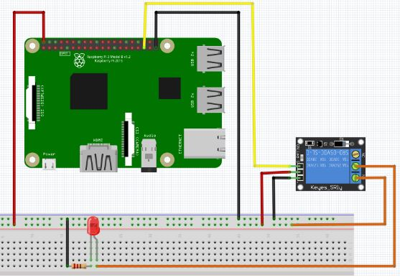

Structure: